Andy Beshear  Governor  Ray A. Perry  Secretary |  | Robert L. Astorino  Executive Director  John L. Hardesty  General Counsel
Kentucky Real Estate Authority
Kentucky Real Estate Commission
Mayo-Underwood Building
500 Mero Street, 2NE09
Frankfort, Kentucky 40601
Phone: (502) 564-7760
https://krec.ky.gov

KENTUCKY REAL ESTATE COMMISSION
(KREC)

MEETING MINUTES
August 19, 2021

* This meeting occurred via Zoom Teleconferencing, pursuant to KRS 61.826*

Commission Members Present

Commissioner Chair, Lois Ann Disponett
Commissioner Larry Disney
Commissioner James Simpson
Commissioner Steve Cline
Commissioner Raquel Carter
Commissioner Anthony Sickles

KREA Staff

Robert Laurence Astorino, Executive Director
John Hardesty, General Counsel
Hannah Carlin, Education and Licensing Coordinator
Brian Travis, Investigator
Terri Hulette, Executive Administrative Secretary
Angie Reynolds, Administrative Specialist III

Guests Present

502-558-8894
Sue Collins
Tara Wilson
Veronica Dickerson
Peggy Smith
Pam Featherstone
Joyce Sterling
Richard Wilson
Margie Harper
Linda Cecil
Ron Brossart
Janie Wilson
Tom Cox
Jim DeMaio, RASK
Mike Lawrence
Kim Whalen
Marcie Estepp
Linda Flickinger
Rhonda Richardson
Ken Warden
Jaclyn Graves
Jeff Smith
Jennifer
Phaedra
Twilla Williams
Ronald Hughes

Call to Order and Guest Welcome

The Kentucky Real Estate Commission meeting was called to order through video teleconference by Commission Chair, Lois Ann Disponett, at 9:00 a.m. on August 19, 2021. Roll call was taken and a quorum was present. Guests in attendance were welcomed and introductions of guests, staff, and commissioners were made.

Approval of Meeting Minutes
Commissioner Simpson made a motion to approve the July 15, 2021 Meeting Minutes. Commissioner King seconded the motion. With all in favor, the motion carried.
Commissioner Cline made a motion to approve the August 6, 2021 Forms Committee Meeting minutes. Commissioner King seconded the motion. With all in favor, the motion carried.

Education and Licensing Report

Ms. Hannah Carlin presented the Commission the following:

- PSI Testing Statistics

July 2021 (First Time)
Type of Exam | Passed | % Passed | Failed | % Failed | Total Exams
License Reciprocity- Broker | 1 | 50.00 | 1 | 50.00 | 2
License Reciprocity- Salesperson | 8 | 57.14 | 6 | 42.86 | 14
Broker- National | 6 | 50.00 | 6 | 50.00 | 12
Broker- State | 5 | 38.46 | 8 | 61.54 | 13
Salesperson- National | 121 | 75.63 | 39 | 24.38 | 160
Salesperson- State | 79 | 49.07 | 82 | 50.93 | 161
TOTAL | 220 | 60.77 | 142 | 39.23 | 362

July 2021 (Repeat)
Type of Exam | Passed | % Passed | Failed | % Failed | Total Exams
License Reciprocity- Broker | 2 | 66.67 | 1 | 33.33 | 3
License Reciprocity- Salesperson | 4 | 80.00 | 1 | 20.00 | 5
Broker- National | 10 | 62.50 | 6 | 37.50 | 16
Broker- State | 5 | 45.45 | 6 | 54.55 | 11
Salesperson- National | 26 | 31.71 | 56 | 68.29 | 82
Salesperson- State | 51 | 45.13 | 62 | 54.87 | 113
TOTAL | 98 | 42.61 | 132 | 57.39 | 230

2021 (Cumulative)
Type of Exam | Passed | % Passed | Failed | % Failed | Total Exams
License Reciprocity- Broker | 15 | 51.72 | 14 | 48.28 | 29
License Reciprocity- Salesperson | 63 | 64.95 | 34 | 35.05 | 97
Broker- National | 76 | 62.30 | 46 | 37.70 | 112
Broker- State | 65 | 52.42 | 59 | 47.58 | 124
Salesperson- National | 1,002 | 59.57 | 680 | 40.43 | 1,682
Salesperson- State | 987 | 52.87 | 880 | 47.13 | 1,867
TOTAL | 2,208 | 56.31 | 1,713 | 43.69 | 3,921

- Licensing Statistics
As of August 10, 2021
Type | Active | Inactive | TOTAL
Sales Associate | 11,974 | 5,719 | 17,693
Broker | 3,846 | 813 | 4,659
TOTAL | 15,820 | 6,532 | 22,352

Licensees cancelled in June 2021: 30 (8 brokers, 22 sales associates)

New Licenses Issued in 2021 (by month)
Month | Sales Associate | Broker | Total
January | 109 | 10 | 119
February | 172 | 14 | 186
March | 122 | 5 | 127
April | 163 | 12 | 175
May | 138 | 7 | 145
June | 138 | 8 | 146
July | 151 | 14 | 165
August
September
October
November
December
TOTAL | 993 | 70 | 1,063

The August 2021 Continuing Education Applications were reviewed for compliance with 201 KAR 11:170 and recommended to the Commission for approval by Hannah Carlin.

Commissioner Cline made a motion to approve the list of applications. Commissioner Simpson seconded the motion. Commissioner Disney abstained from the discussion and the vote. Remaining all in favor, motion carried.

Ms. Carlin presented the August 2021 licensing requests:

- 271470: Commissioner Cline made the motion to deny. Commissioner King 2nd. Commissioners Carter and Disney voted ‘nay’ motion carried.

- 271984: Commissioner Simpson made the motion to deny. Commissioner King 2nd. Having all in favor, motion carried.

- 272146: Commissioner Disney made the motion to approve. Commissioner Simpson 2nd. Having all in favor, motion carried.

- 272154: Commissioner Simpson made the motion to approve. Commissioner Disney 2nd. Having all in favor, motion carried.

- 272149: Commissioner Simpson made the motion to approve. Commissioner Disney 2nd. Having all in favor, motion carried.

- 272557: Commissioner Simpson made the motion to approve. Commissioner King 2nd. Having all in favor, motion carried.

PSI Testing Issues
Commission Staff has recently received many concerning calls and emails regarding PSI’s services. Ms. Carlin, General Counsel and the Director met via Zoom with one of PSI’s main representatives, Mr. Munn. They informed him that there has been some concerning issues relating to poor customer service. Such as incorrect information from the call center advising licensees regarding what exams to take (not the role of PSI), and testing centers failing to follow COVID protocol.

Since their meeting, Mr. Munn has provided a plan of action as to what PSI plans to do to improve their services. In regards to customer service, they now have a dedicated line at the PSI call center just for Kentucky. This should help to reduce the wait time. PSI will also be updating all their information for their customer service representatives. They have been advised not to divert from that information. In addition PSI will be working with their Special Accommodations Department as to ensure that any requests for testing accommodations are handled in a timely manner. PSI is also working to make sure that their system is flagging people and not letting them continue the exams when they have answered ‘no’ to any of the red flag questions.

National Criminal History Checks
Ms. Carlin wanted everyone to be aware of the background check requirements. There have been a lot of issues with the timing of many applicants’ background checks. Ms. Carlin re
iterated the statute and the regulation KRS 324.045 Section 5(C) and 201 KAR 11:210 Section 6 (1). Background checks are valid for ninety (90) days from the date of the record report. This is a regulatory requirement and she asks that people pay attention to meeting those requirements in the order that they are supposed to.

Executive Director Comments
Director Astorino announced Cabinet Secretary Harvey has been reassigned by the Governor to the Justice Cabinet and Deputy Secretary Ray Perry will be taking his place. Jacob Walbourn and Mona Womack will also be leaving with Secretary Harvey. These individuals have been great to work with and will be missed.

We are still waiting to hear from Illinois and Indiana as to finalize our Reciprocity agreements with them. Both have license designations that are somewhat different from our own and required a bit more creativity. We have them in a final form and after GC reviews them we will send both to their prospective states for review. Once completed each will be presented to the Cabinet for approval.

The Insurance Initiative is moving forward, there were some corrections but it will be corrected and resubmitted to the Department of Finance this afternoon. The time line was to have it submitted by October 1st, which we are well ahead of. So the Biennium Insurance that had previously been approved by the Commission is still on track and moving forward.

Director noted that he is seeing good results in the area of complaint reduction. They haven’t all gone away, but complaints are being addressed in an effective manner. A docket tracker form for each of the KREA four Boards has been created. It is a tool of measurement as to where we are today in terms of open cases as to what we started the year with and what we end with.

Note regarding PSI, he felt Ms. Carlin did a great job negotiating with their representative, getting the issues that needed to be addressed clearly stated and down on paper. By Wednesday the representative responded with a plan to resolve those issues. By the next meeting he will have followed up with Ms. Carlin concerning PSI’s execution and have her report on their progress.

The Indiana reciprocity agreement will be fairly different than that of the other reciprocity agreements so far. Both Indiana and Illinois are what we call Broker States. The first tier license issued in our state is called an Associate license, theirs is called a Broker’s license. That in itself does not defeat the reciprocity. Illinois has very similar education requirements. But in Indiana’s case they do not. The Director and Ms. Carlin spoke with one of Indiana’s Deputy Attorney General and the head of their Real Estate Commission the beginning of July 2021. They’re licensee numbers are very different then our own. We are going to reciprocate only the entry level licensing, making the Kentucky Associates license equal to the requirements for the Indiana Broker license. Their second tier is called a Managing Broker Eligible, but there is not enough comparability and no educational requirement alignment as needed to qualify for our second tier Broker’s license. Because of this KREC will not be reciprocating with Indiana at the Kentucky Broker level. The plan is that anyone that comes to either state with a reciprocal license would follow the rules of that reciprocating state. Though they will not be able to get their Broker’s licensing with reciprocity through the state of Kentucky. It is not a good policy to issue a reciprocated license that does not meet the educational equivalent to our own, which is quite high.

Committee Reports

Education Committee
There was no Education Committee meeting for this month.

Diversity, Equity, & Inclusion Subcommittee
Commissioners Sickles and Carter have created an outline of Diversity, Equity, & Inclusion narrative for the Director and GC to review. Once reviewed they will present it to the Commission and then for public comment. It is a process.

Commissioner Carter recapped the expectations of the Committee when it was formed. They had wanted from the KREC level to lead by example and by policies. They were able to put their best foot forward by showing our commitment to fairness, respect, diversity, equity, & inclusion for all people. They felt that this was important to protect the public and the consumer, including fostering this type of diversity, equity, & inclusion in the industry. They have outlined their initiative and their four key goals. Which include data collection, education, outreach and career support.

The data collection seems to be more difficult than they imagined. However they decided to focus on things that they can immediately impact, such as the creation of a KREC Minority Real Estate Scholarship. It does appear that there are some gaps in KREC’s representation within some minority groups, the purpose is to rectify that. In doing so, they would like to focus on the career support aspect. They would like our numbers to become more reflective of the public that we serve. They want to give people the opportunity to be successful and professional. They have bullet pointed their outline for the scholarship program, which includes both scholarship and mentorship opportunities. In addition to monitory awards up to $5000 per award, to be not only be used towards pre-licensing courses but also college related courses in real estate and possibly it could also go towards a broker’s license. As to encourage people already licensed to move up in the industry. And other development professional courses to be decided later on.

GC noted that he will present this to Cabinet leadership to see how this could be rolled out to the public. He agrees that this is a worthwhile endeavor. If the Committee needs to have any additional meeting to iron out the the details, please do so.

Applicant Review Committee
Commissioner Simpson read the report of the Application Review Committee and the Committee’s recommended action on each licensee:

At this time the Applicant Review Committee made the following recommendations:

- To approve C.S. a license.
- To approve D.Y. a license.
- To defer M.H. for further investigation.

Complaint Review Committee
General Counsel, on behalf of the Complaint Review Committee, read the report of the Complaint Review Committee, and the Committee’s recommended action on each Complaint, to be further discussed in Executive Session. The Committee’s recommendations are as follows:

Final Adjudications

- 20-C-024 – The Complainant alleged that Respondent’s family’s company sued Respondent for unauthorized use of their company name and copyright violations, and was granted summary judgment and injunctive relief on August 8, 2020 to stop Respondent (also a family member) from using their last name in his company’s name and to discontinue advertising under such name. The Complainant claims the Respondent attempted to reargue this issue and was denied. The Court found the Respondent to be in contempt for failing to desist from using the name. The Complainant claims Respondent was ordered to remove all signs placed by him or anyone on his behalf. She claims he is defying the court order by continuing to use the name by advertising in the KCREA and on his signage using the name.

The evidence suggests that the Respondent’s counsel failed to timely respond to a motion for summary judgment filed by his family’s company, which caused the court to grant the motion and enter an injunction against Respondent requiring him to cease from using the name family name. Respondent claims he did not know this order had been entered, or anything else that was going on in the case, because his attorney did not communicate with him. He has filed a complaint against the attorney with the Kentucky Bar Association, and implies he may file a legal malpractice suit.

The evidence suggests that the Respondent is not currently using the name in advertising or as his business name. Further, because his company name actually included the family name, advertising under the name was not false or misleading. Violation of copyright laws, while possibly grounds for separate legal recourse, do not give rise to violations of KRS 324.160 in this context. The Committee recommends dismissal of the complaint.

- 20-C-035 – The Complainant claimed he purchased a home in 2017 that was marketed as 2,715 square feet. He also claimed the home was marketed as having a clubhouse, fitness room, pool, and tennis courts, but that those actually belonged to a neighboring community. He claims when preparing a legal separation agreement, he came across conflicting information and ultimately determined the square footage of the home was 2,362 square feet. He claims when providing him with updated information at the time of the separation, the Respondent agent marked out the 2,715 every place it appeared and wrote in 2,362.

Because the complaint appeared to have been filed outside of the one year statute of limitations, Commission staff requested a sworn supplement from Complainant. In the supplement, he claims he had no reason to suspect a discrepancy between the stated and actual square footage until January 2020. The Committee determined the Respondent knew or should have known of all alleged violations more than one year prior to the date he filed the complaint. The Committee recommends dismissal of the complaint because it was filed outside of the one year statute of limitations.

Pending Actions

- 20-C-025 - The Committee found evidence of violations and recommends a formal reprimand, a $1000 fine, and 6 hours of CE in advertising in addition to existing CORE requirements.

- 20-C-027 – The Committee recommend to refer the case for further investigation.

- 20-C-033 – The Committee recommend to refer the case for further investigation.

- N.C. Unlicensed Brokerage – N.C.’s license has been cancelled since April 2, 2021 for failure to maintain E&O Insurance. The Commission received evidence N.C. has actively been working during his cancellation. The Committee recommends to the Commission to investigate N.C. unlicensed brokerage activities.

Executive Session Legal Matters and Case Deliberations
At 9:57 a.m. Commissioner Simpson made a motion to enter executive session, pursuant to KRS 61.810(1)(c) and (j), and KRS 61.815 to deliberate on individual adjudications and to discuss 3 new applications and the 6 above CRC case recommendations as offered by Commissioner Disney:

- 20-C-024
- 20-C-025
- 20-C-027
- 20-C-033
- 20-C-035
- N.C. Unlicensed Brokerage

Commissioner King seconded the motion and the Commission entered into closed session discussion.

Reconvene Open Session and Committee Recommendations
Commissioner Cline motioned for the Commission to come out of executive session and Commissioner Simpson 2nd the motion. Commission Chair Disponett resumed the full Commission meeting at 10:14 a.m. and welcomed everyone back attending the teleconference Commission meeting.

Commissioner Simpson made the motion to adopt the Applicant Review Committee items as previously recommended to the Commission. Commissioner Cline 2nd the motion. Having all in favor, motion carried.

Commissioner Disney made the motion to adopt the Complaint Review Committee recommendations as previously stated to the Commission. Commissioner Cline 2nd the motion. Having all in favor, motion carried.

Agency and Disclosure Form Revisions
General Counsel briefly went through each of the most recent revisions from the Forms Committee before the Commission.

- KREC Form 400: A Guide to Agency Relationships
- KREC Form 401: Agency Consent Agreement (Buyer)
- KREC Form 401: Agency Consent Agreement (Seller)
- KREC Form 402: Seller’s Disclosure of Property Conditions

Public Comment
Chairperson Disponett opened the floor for public comments.

Rhonda Richardson requested to address the Commission. She asked that they reconsider their decision to remove the ‘unknown’ category from the KREC Form 401: Agency Consent Agreement (Seller) because she still feels that it is in the best interest of the consumer.

Michael Lawrence asked for the same consideration. He expressed concern for consumers that may inherit a property and have no knowledge about the property.

Richard Wilson asked if approved by the Commission, when would the forms be filed with the Legislative Research Committee (LRC)? GC informed the gallery that it would be after the Director’s approval; it would be 8-10 months between when they’re filed and when they go into effect. This would also include a public forum conducted by LRC.

At this time Commissioner King asked Ms. Carlin and the Director what were the disclosure forms like with the States that we had formed Reciprocity. Ms. Carlin said that she did not know right off, but would be glad to research the matter, even reach out through ARELLO. At this time a few items were found online by Ms. Carlin, Commissioner Disney and GC. The first, a possible Association Seller’s property disclosure form from Florida that was had very limited use of the word ‘unknown’. As was the case for both the Ohio and Tennessee seller’s property disclosure forms.

Commissioner Carter noted that she feels the use of ‘unknown’ may meet the needs of people who inherit property; however it is no different than as if they had walked the property and noted a leak or remembered a past conversation with the previous owner about a repair. All of that would need to be disclosed, regardless. But that is not what people are doing. They simply checking ‘unknown’ across the board thinking that it absolved them of all liability. The answer would still be true if answered honestly ‘to the best of your knowledge ….yes or no’.

Commissioner Simpson stated that he recently filled out a few seller property disclosure forms. Being an opponent of the over use of the word ‘unknown’, he told his time and he really felt that he filled out the form more completely as if he had just checked ‘unknown’. Though ‘unknown’ can still be written in when it applies.

At this time Commissioner Simpson made the motion to adopt the forms as presented by the GC and the Form Committee, Commissioner Disney 2nd the motion. Commissioner Cline voted ‘nay’ having the majority in favor, motion carried.

Legal Report
Docket Update
GC noted that the Docket tracking system developed by Ms. Reynolds has really helped to follow the headway made by legal team has been able to make since this group started back last April. Currently there are still over 100 open complaints and there appears to be a bit of an uptick in new complaints. This maybe due to the increase in market activity. We receive many complaint inquiries on a regular basis via phone and email. GC thanked both Brian Travis and Angie Reynolds for their diligence.

The primary respondent in our largest case, comprised of 12 complaints, whom has never participated in any of the case process, even after being served by the County Sheriff’s Department, is in Hearing right now. We recently received a default judgment against her. Next step will be the Recommended Order from the Hearing Officer which will deal with the disciplinary action. This will then go to a Recovery Fund hearing in the first week of November. All the clients that were harmed in this complaint will have to prove their damages.

There are currently a few other cases that have scheduled for disciplinary hearings in the next few weeks. There are others that we are currently working to file a notice of Administrative Hearing on. The docket is moving forward. There have been a lot of complaints that have been reviewed by the Commission that need a settlement negotiation or a notice drafted. If anyone has any questions or concerns regarding the status of cases please do not hesitate to reach out to one of the legal team.

New Business
KYR Convention
The Kentucky Real Estate Commission’s meeting scheduled for September 16, 2021 will be cancelled. Instead the September meeting is scheduled, pending approval, to be held at the KYR Convention September 29, 2021 from 2 – 4 p.m. at the Cincinnati Marriott at River Center. COVID mandate would be in effect.

This meeting will be in person and will not be broadcast on Zoom.

ARELLO Convention
The Association of Real Estate Licensed Law Officials (ARELLO) Convention has been put on hold. Chairperson Disponett noted that it had been discussed that if found to be cost efficient ARELLO would consider conducing many of the sessions via Zoom.

Approval Per Diem
- Commissioner Carter made a motion to approve the per diem for Commissioners Disney and Commissioner Simpson for the attendance of the August 6, 2021 Forms Committee Meeting. Because it was teleconferenced, there were no travel expenses. Commissioner Cline 2nd the motion. Having all in favor, the motion carried.
- Commissioner Sickles made a motion to approve the per diem for Commissioners Simpson and Commissioner King for the attendance of the August 18, 2021 ARC Meeting. Because it was teleconferenced, there were no travel expenses. Commissioner Cline 2nd the motion. Having all in favor, the motion carried.
- Commissioner Simpson made a motion to approve the per diem for Commissioners Sickles and Commissioner Disney for the attendance of the August 18, 2021 CRC Meeting. Because it was teleconferenced, there were no travel expenses. Commissioner Carter 2nd the motion. Having all in favor, the motion carried.
- Commissioner Simpson made a motion to approve the per diem for the August 19, 2021 KREC Regular meeting. Because it was teleconferenced, there were no travel expenses. Commissioner Disney 2nd the motion. Having all in favor, the motion carried.

Meeting Adjournment
The Commission will hold a special meeting on Wednesday, September 29, 2021 at 2 p.m. local time at the Cincinnati Marriott at River Center, 10 West River Center Boulevard, Covington, KY 41011.

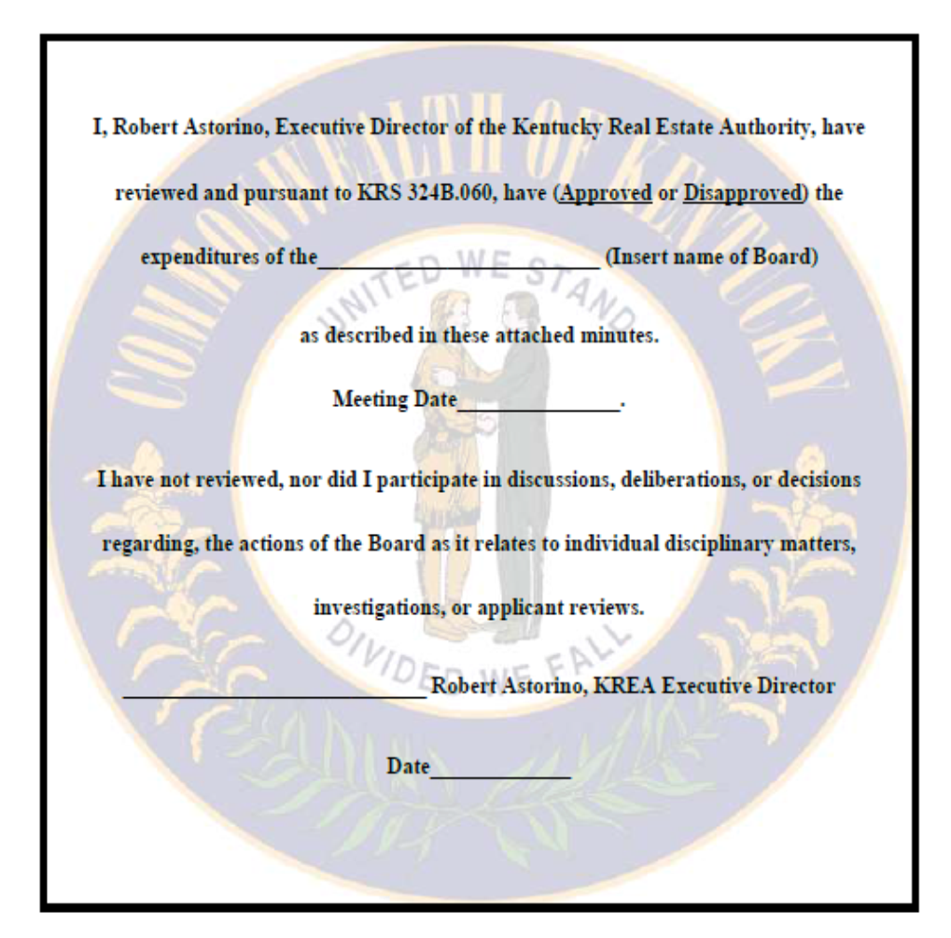
Commissioner King made a motion to adjourn the meeting. Commissioner Simpson seconded. Meeting adjourned at 10:58 a.m.
Kentucky Real Estate Commission
August 19, 2021
August 19, 2021

